Assignment 9 worksheet

FINAL PROGRAMMING PROJECT – source code file(s)

This ASSIGNMENT contains the following activitY:

|  |  |
| --- | --- |
| Activity 9.1 | Submit the source code file(s) and screen shot for your selected programming project |
|  |  |

|  |  |
| --- | --- |
| Activity 9.1 | Submit the source code file(s) for your selected programming project |
| Overview | In Activity 9.1 you submit the source code file(s) for your selected programming project. You should deliver to your instructor the source code file(s) of your final programming project connecting the multiple topics we have learned. |

You should deliver to your instructor the source code file(s) of your final programming project connecting the multiple topics, we have learned, such as:

* Textbook Chapters 3-8, 10-12 & 14.
* Textbook theory and Programming Challenges (Review source code solutions in BlackBoard - Learning Modules)
* MPL Programming Projects: Chapters 3-8, 10-12 & 14.

This source code file(s) will serve as the foundation of your Final Programming Project. See your syllabus (Final Project - 4 parts) or the schedule below for details:

|  |  |  |
| --- | --- | --- |
| **Week** | **Assignment This Week** | **Due Date** |
| 11 | *Final Project – Part* ***1*** */ 4 (Choose 1 and begin)* | *10/29* |
| 13 | *Final Project – Part* ***2*** */ 4 (Submit Progress Report)* | *11/12* |
| 15 | *Final Project – Part* ***3*** */ 4 (Submit Pseudocode)* | *12/3* |
| **16** | ***Final Project – Part 4 / 4 (Submit Source Code Files)*** | ***12/10*** |

The Requirements for your final project - source code file(s) are:

1. Submit in BlackBoard your source code file(s) as an attachment. For example: “MyFirstProgram.java”; “MyLastProgram.java”
2. After compiling your source code file(s), Submit in BlackBoard the compiled file as an attachment. For example: “MyFirstProgram.class”; “MyLastProgram.class”.
3. After running your compiled file(s) successfully (or partially). Take a screen shot of the Output by pressing Alt+Prt Scr and then paste it here (into your CISC190 - Assignment09_worksheet in the Appendix 2) file by pressing Ctrl+V.

**Table of Contents**

Appendix 2 4

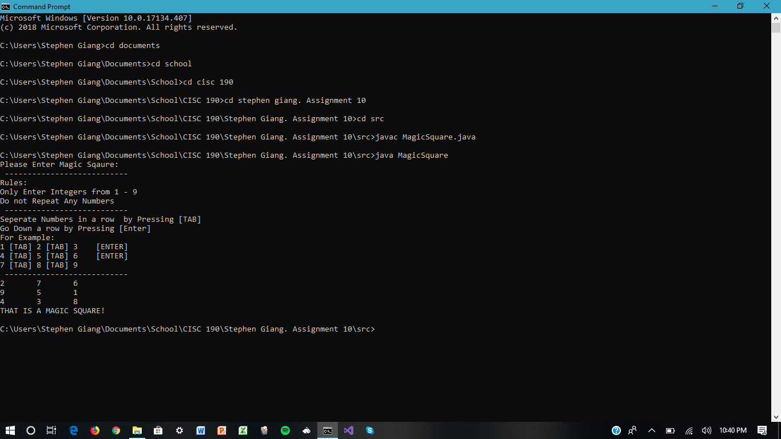

Appendix 2

**<< Paste Your “Final Project - Screen shot of the Output” Below >>**

After running your compiled file(s) successfully (or partially). Take a screen shot of the Output by pressing Alt+Prt Scr and then paste it here. To use this page of the template, simply delete this paragraph and start typing. The formatting should stay the same.

**Note:**

*Once you have filled in the required information, save the file to your flash drive / hard disk. Then, you can submit it to your instructor through your Blackboard Course for review and grading.*